The title should be bold and centered (Times New Roman in 14pt)

A. Author^{1*}, B. Author², and C. Author³ (Times New Roman in 11pt)
¹ Laboratory, Department, University, Address, City, State, Zip code, Country
² Group, Department, University, Address, City, State, Zip code, Country
³ Laboratory, Division, Institute, Address, City, State, Zip code, Country
(Italicized Times New Roman in 11pt)

Corresponding-author@rice.edu (Times New Roman in 11pt without hyperlink)
*presenting author

1. Layout and file settings
This page presents instructions for preparing camera-ready abstracts for 2023 Rice SIMS workshop. All abstracts should be submitted as a PDF file (.pdf) using the following guidelines. The length must be one page including figures and tables. The abstract book will be printed in color. Use Letter (8.5 inch × 11 inch) size paper, making sure that there is a margin of 1 inch on top/bottom/left/right sides. As the default setting of this file, we recommend embedding all the fonts used in your abstract.

2. Text, Tables, Figures, Equations, and References
In the main text, Times New Roman font in 11pt size and single line spacing should be used. Use Symbol font for Greek letters. Otherwise, the main text can be written in free format. Samples of tables, figures, equations, and references are shown as follows.

Table 1. Table caption (Times New Roman in 9pt) above is preferable to be centered.
 | A = 0.56 | B = 0.69 | C = 0.75 | D = 0.100
AB₁ | 14.0640 | 18.5620 | 22.0817 | 18.90732
DA₅ | 246.7889 | 255.9483 | 284.6633 | 262.24264

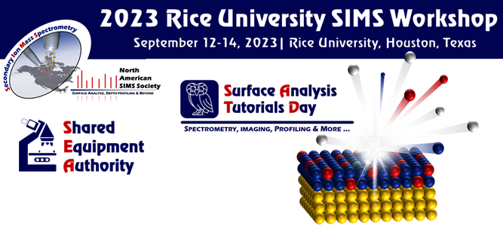
Figure 1. Figure caption (Times New Roman in 9pt) below is preferable to be centered

Displayed equations, e.g., “Eq.(1)” are preferable to be indented or centered.

References
Times New Roman font in 11pt should be used. All of the references are recommended to be numbered in the order that they appear in the abstract. It is recommended to use numbers in square brackets in the text where a paper is cited (e.g., [1]).

[1] You can write each item in free format.
[2]…

